Daniel McDonough
CS549
9/4/19

1.
Similar:
- Can compute images with multiple lenses (or two eyes)
- Both taken images are inverted
- Both have the functionality of controlling aperture via a hole in the lens or pupil
- Both (typically) have curved lenses
- Both have a limited field of vision (the range may vary but still limited)
Different:
- Cameras’ record images for later viewing, eyes don’t (or at least not in reliable high quality)
- Cameras don’t have a “blind spot,” while eyes do
- Camera’s have an easily adjustable wide range shutter speed, while eyes do not
- Eyes can dry out while cameras typically cannot
- Eyes have cones and rods while Cameras have film or a photon sensor
2.
world point, Xw = [xw,yw,zw], camera point Xc = [xc,yc,zc], focal vector F = [0,0,f].

A ray leaving Xw with a slope of 0 (or parallel to the z axis), such that the slope of the bend from Xw to Xc = 0 + -r/f, as -r =yw. If the image is in focus then, there is no blur circle, such that Xc can be linearly transformed to point Xw by the magnification M.

As zc = f, and Xw and Xc are relative to each other by M = f/zw such that Xc = M*Xw.
Then Xw = Xc/M = Xc * M⁻¹

Therefore the image must me in focus when Xw = Xc/M = Xc * M⁻¹ and Xc = M*Xw

if yw/zw = yc/zc (ratios are the same)
then yw/yc = -zw/zc = -zw/f = M⁻¹

if -yc/f = yc + yw / zw

then -yc*xw/(yc+yw) = f

then 1/f = (yc+yw) / -yc*zw
1/f = yc/-yc*zw + yw/ yc*zw
1/f = 1/-zw + yw/yc*zw
1/f = 1/-zw + yc/yc*zc
1/f = 1/-zw + 1/zc

Then 1/-zw + 1/zc = 1/f

Therefore the image must be in focus when 1/-zw + 1/zc = 1/f

3.
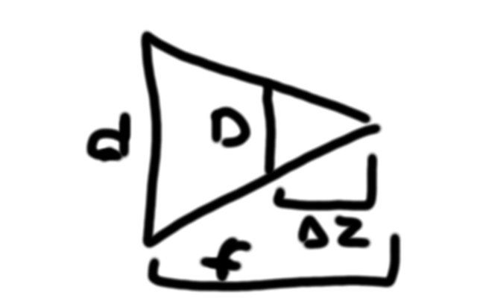
A ray leaving Xw with a slope of 0 (or parallel to the z axis), such that the slope of the bend from Xw to Xc = 0 + -r/f, as -r =yw. As the equation is reversable it also applies to Xc to Xw therefore the lens of the diameter, d, is a scalar to determine the base size of the blur circle.

As the camera point shifts by delta z, either positively or negatively as the rays from Xw continue to form a circle in a radius determined by the ratio of th magnification and the point shift.

Assume the rays from Xw produce an equalateral triangle through a lens with diameter d. then the hight of the triangle at perfect focus is zc and the point |delta z| determines the height of the cross section to be taken.

Therefore the ratio D/d = delta z / f

As such D = d(delta z / f)

4.

  - 2PIr² = surface area = 9cm² = 90 mm²
  - 150000000/90 ~= 1666666 receptors per mm²
- yw/zw = yc/zc
  - zw = 225000000km
  - f = zc= 2.4cm = 0.000024km
  - yw = 8000km
  - yc = yw/zw * zc = 8.5*10⁻¹⁰km
  - 8.5*10⁻¹⁰ * 1000000 = 0.00085
  - 0.00085 * 1666666 ~= 1416 receptors

5.
Rw projects onto Lc iff every element in Rw projects onto Lc.

if sc is a projection of sw and tc is a projection of tw then by definition all elements of sw is mapped to sc and tw to tc.

Rw = [1,A]
Lc = [1-B,B]

IFF, B is not negative or greater than 1 and related to A by the magnification of the lens, is Lc a projection of Rw

